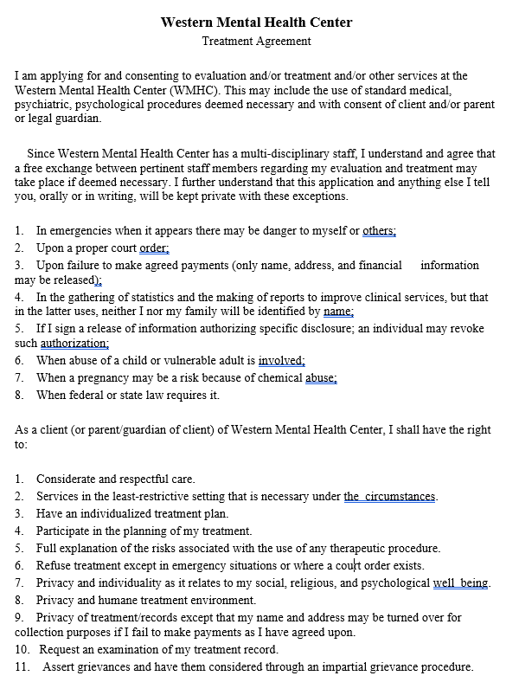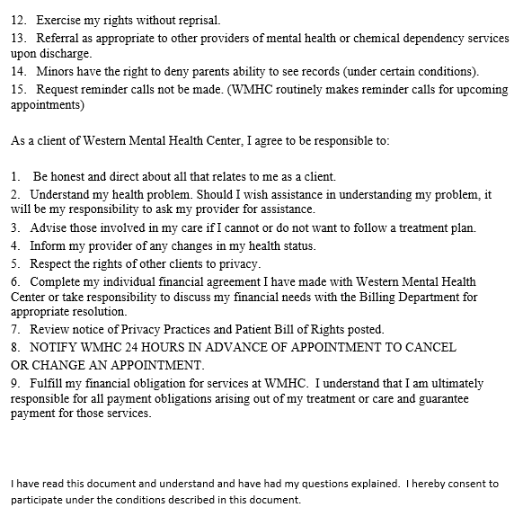

Print Client Name:

Client Signature: Date:

________________________________ ____________________ ____________
Parent or Legal representative signature Relationship Date

______________________________________ _________________
Witness Date
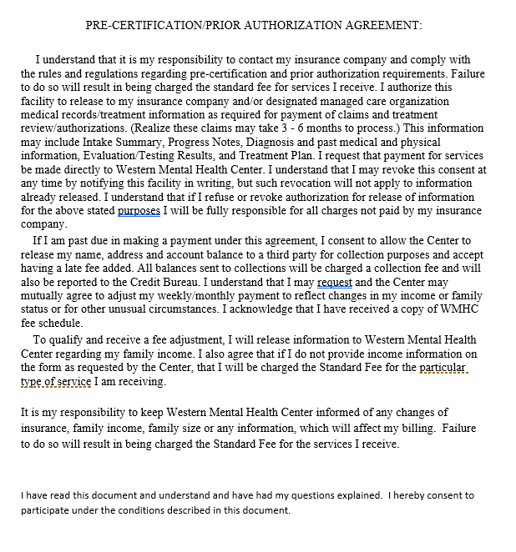Print Client Name:
Client Signature: Date:
________________________________ ____________________ ____________
Parent or Legal representative signature Relationship Date
______________________________________ _________________
Witness Date 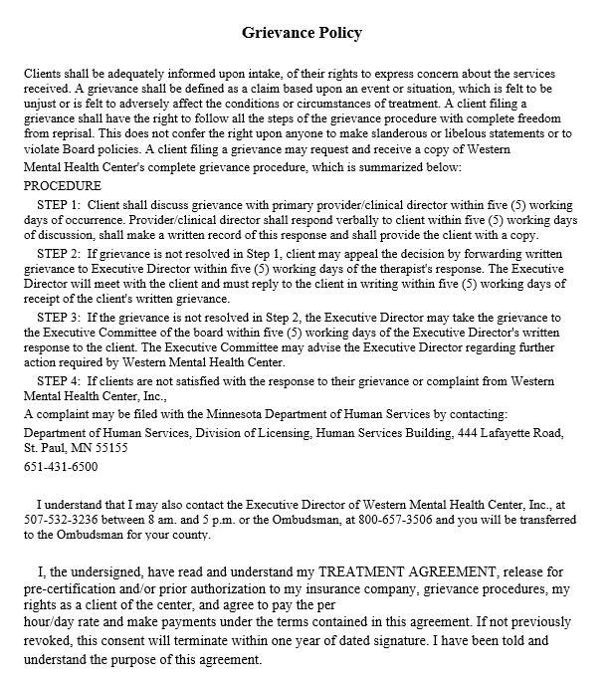Print Client Name:
Client Signature: Date:
________________________________ ____________________ ____________
Parent or Legal representative signature Relationship Date
______________________________________ _________________
Witness Date
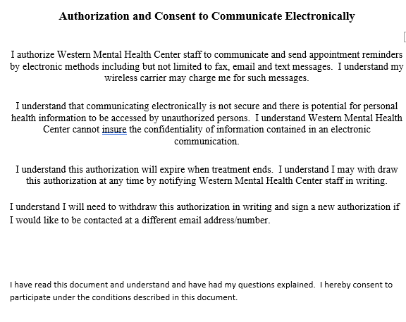

Print Client Name:

Client Signature: Date:

________________________________ ____________________ ____________
Parent or Legal representative signature Relationship Date

______________________________________ _________________
Witness Date

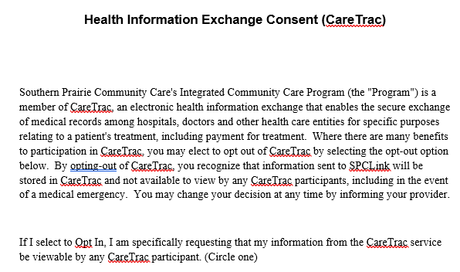
Opt In Opt Out (check preference)

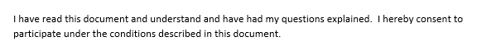
Print Client Name:

Client Signature: Date:

________________________________ ____________________ ____________
Parent or Legal representative signature Relationship Date

______________________________________ _________________
Witness Date
Consent to share medical information
Yes No
Consent Period:

Exclusions Yes or No
If Yes select:
Check the box of the section(s) you wish to exclude
Allergies  Clinical Instructions  Encounters  Medications  Medications Administered  Patient Decision Aids  Pending Diagnostic Tests  Referrals to Other Providers  Care Plan  Cognitive & Functional Status | Immunizations  Procedures  Smoking Status  Care Team  Encounter Diagnosis & Problems  Lab Tests & Results  Reason for Visit/Chief Complaint.  Vitals  Future Appointments | Future Tests  Referrals to Other Providers  Assessment  Goals  Health Concerns  Medical Equipment  Problems  Results  Social History

I have read this document and understand and have had my questions explained. I hereby consent to participate under the conditions described in this document.
Print Client Name:
Client Signature: Date:
________________________________ ____________________ ____________
Parent or Legal representative signature Relationship Date

______________________________________ _________________
Witness Date

