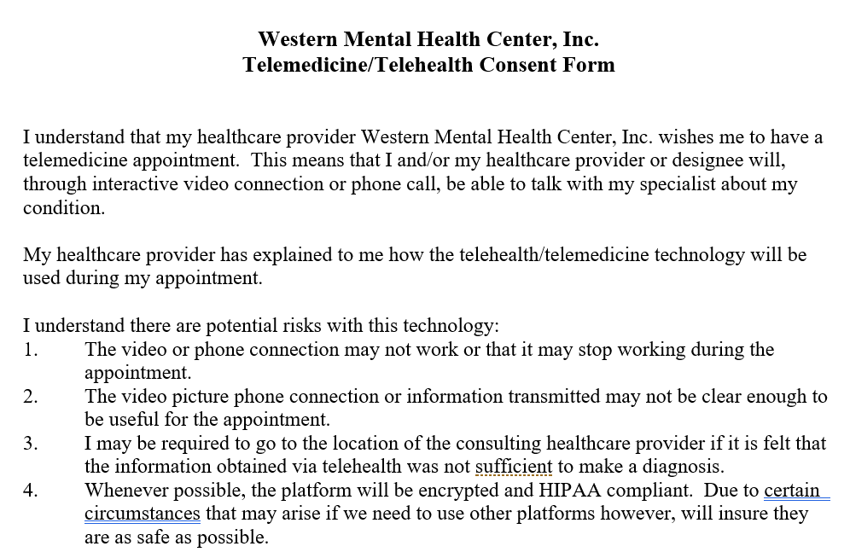

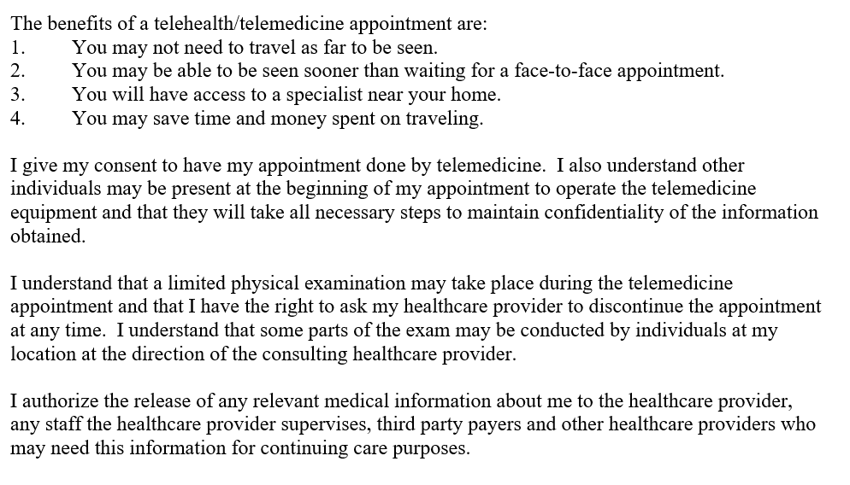

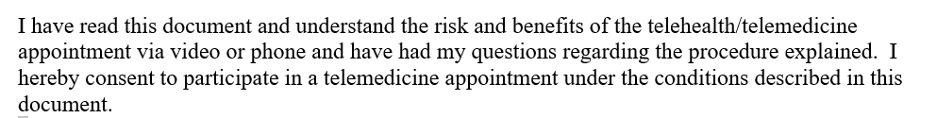

Print Client Name:

Client Signature: Date:

________________________________ ____________________ ____________
Parent or Legal representative signature Relationship Date

______________________________________ _________________
Witness Date

