WESTERN MENTAL HEALTH CENTER
TELEHEALTH PROCESS - CLIENT
APPROVED AS OF: 3/1/20

Hello and welcome to Western’s Telehealth Process!

The first item that we to insure is that you or your parent/guardian have signed a telehealth consent form that is attached. We can accept temporary verbal consents via email or text.

Once you have agreed to a telehealth appointment, your therapist will schedule the appointment via ZOOM and you will receive an invitation either by test or email (example below) that will state you have been invited to a ZOOM meeting.

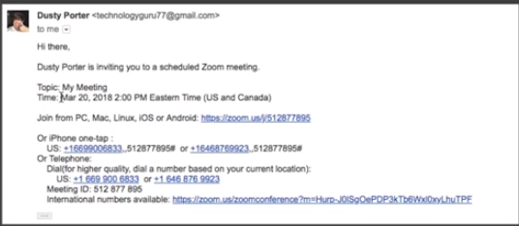

Clicking the link will prompt you to download the ZOOM app, please do so.
At your scheduled appointment time, select the link with Join from PC link (circled and below)

Once you click the link, you will open zoom meeting and your provider will connect with you

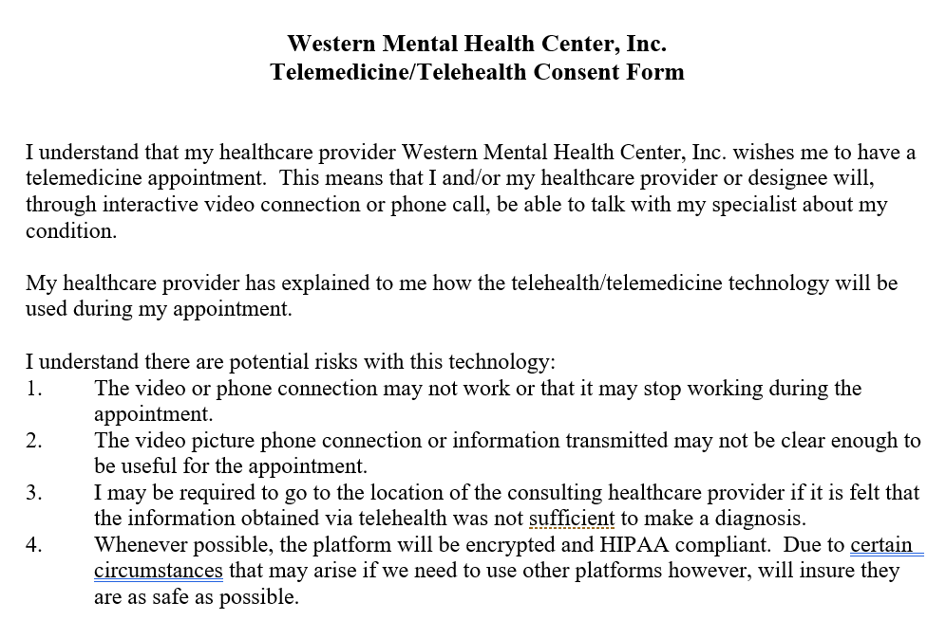

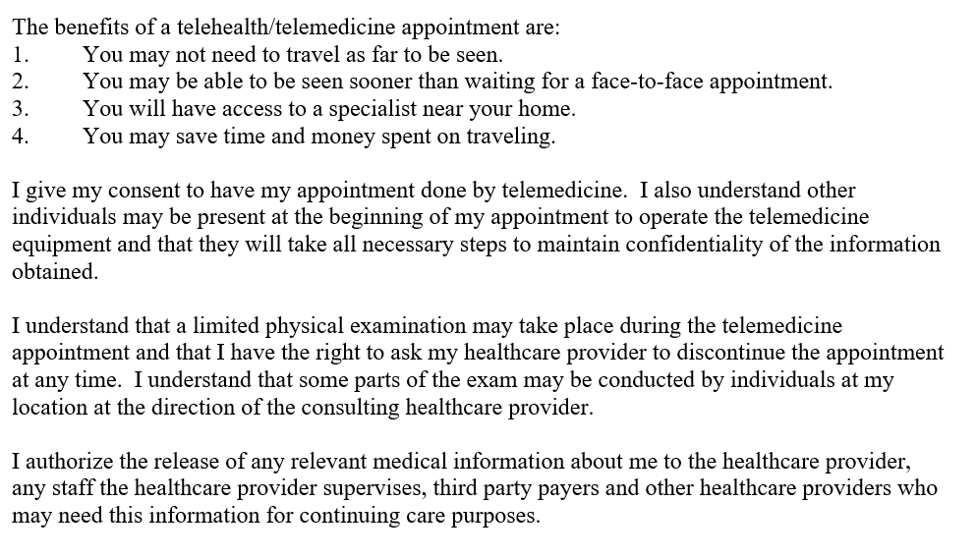

Print Client Name:

Client Signature: Date:

________________________________ ____________________ ____________
Parent or Legal representative signature Relationship Date

________________________________ ____________________ ____________
Patient/legal representative signature Relationship Date

______________________________________ _________________
Witness Date
revised 10-2006

