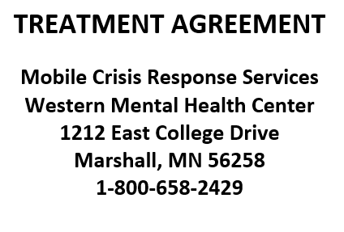

Client:_____________________________________ DOB:___________________

Parent/Guardian:____________________________________________________

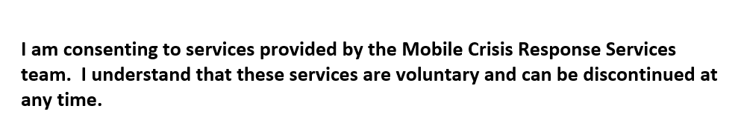

Client Signature:___________________________________
This is my electronic signature and by signing, I attest to the above statement
Date:____________________________________________

Parent/Guardian:__________________________________
This is my electronic signature and by signing, I attest to the above statement
Date:____________________________________________

MCRS Staff:_______________________________________
This is my electronic signature and by signing, I attest to the above statement
Date:____________________________________________

